Jurnal Mercumatika : Jurnal Penelitian Matematika dan Pendidikan Matematika ISSN: 2548-1819
Vol. 3, No 1, April 2017, pp. xx-xx 1

Electronic Student Worksheet Design (ELKPD) Mathematics to Improve Students' Numeracy Literacy and Social Interaction Skills

Haura Amara Rais ¹ , Nafida Hetty Marhaeni ^{1*}
¹ Jurusan Pendidikan Matematika, Universitas Mercu Buana Yogyakarta. Jalan Wates Km. 10 Sedayu Yogyakarta, 55753
* Korespondensi Penulis. E-mail: nafidahm@mercubuana-yogya.ac.id, Telp: +62 85799312507

Abstrak
Literasi numerasi dan interaksi sosial siswa merupakan suatu aspek penting pembelajaran matematika. Literasi numerasi dalam pembelajaran matematika dipengaruhi oleh media pembelajaran yang digunakan oleh siswa. Interaksi sosial yang rendah akan membuat siswa tidak bersemangat belajar matematika, sehingga dapat membuat hasil belajar rendah. Oleh karena itu, tujuan penelitian ini adalah menganalisis kebutuhan media pembelajaran matematika untuk meningkatkan literasi numerasi dan interaksi sosial siswa. Penelitian yang digunakan yaitu penelitian kuantitatif deskriptif. subyek penelitian merupakan siswa kelas VII A SMP Negeri 2 Godean. Teknik pengumpulan data yang digunakan adalah wawancara, observasi, dan angket. Hasil penelitian menunjukkan 80% literasi numerasi siswa sedang cenderung rendah. Selain itu, 90% penggunaan buku dan metode konvensional menjadi faktor utama literasi numerasi dan interaksi sosial siswa rendah. Kebutuhan media pembelajaran matematika menjadi penting karena 72% siswa setuju dengan penggunaan media pembelajaran matematika. Oleh karena itu, dibutuhkan pengembangan media pembelajaran matematika untuk meningkatkan kemampuan literasi numerasi dan interaksi sosial siswa.

Keyword: Validitas, ELKPD, Literasi numerasi, Interaksi sosial

Abstract
Students' numeracy literacy and social interaction are important aspects of mathematics learning. Numeracy literacy in mathematics learning is influenced by the learning media used by students. Low social interaction will make students unenthusiastic about learning mathematics, which can result in low learning outcomes. Therefore, the purpose of this study was to analyze the need for mathematics learning media to improve students' numeracy literacy and social interaction. The research used was descriptive quantitative research. The subjects of the study were students of class VII A of SMP Negeri 2 Godean . The data collection techniques used were interviews, observations, and questionnaires. The results showed that 82% of students' numeracy literacy was moderate to low. In addition, 90% of the use of books and conventional methods was the main factor in low numeracy literacy and social interaction of students. The need for mathematics learning media is important because 72% of students agree with the use of mathematics learning media. Therefore, the development of mathematics learning media is needed to improve students' numeracy literacy and social interaction skills.

Keyword: Validity, ELKPD, Numeracy literacy, Social interaction

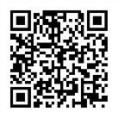W : http://ejurnal.mercubuana-yogya.ac.id/index.php/mercumatika

DO
I
:

E : mercumatika@mercubuana-yogya.ac.id
2 Jurnal Mercumatika : Jurnal Penelitian Matematika dan Pendidikan Matematika ISSN: 2548-1819
Vol. 3, No. 1, April 2017, pp. xx-xx

INTRODUCTION
Education in the digital age has become a widely discussed topic, including in Indonesia. Education continues to evolve over time, as does knowledge, in line with the advancement of modern technology (Julita, 2022). Education equips people with conceptual and procedural skills, and guides their thinking skills in applying the concepts and procedures learned through education (Anderha, 2021). One way to achieve this is through mathematics learning, which plays a crucial role in developing logical thinking, problem-solving, and analytical skills, essential for success in the modern era (Gestiardi, 2025).
Science and technology can be learned by humans with adequate literacy skills. With high literacy skills, it can encourage the development of science and technology to a higher level, in addition to literacy skills, numeracy skills also have a very large role to be mastered (Siskawati, 2021). Numeracy Literacy is the ability possessed by individuals to apply, formulate and describe mathematics in various situations, which includes the ability to reason mathematically and use concepts, procedures, and facts as a description, explanation or estimate of a phenomenon or event (Kusniati, 2018). Based on interviews with mathematics teachers of SMP Negeri 2 Godean, teachers see that students' numeracy literacy skills are still low. This is supported by the results of the pretest of numeracy literacy skills conducted in grade VII students of SMP Negeri 2 Godea where the results showed that more than 80% of students had low numeracy literacy skills. Therefore, the numeracy literacy skills of grade VII SMP Negeri 2 Godean need to be improved.
Student social interaction is also a major factor in learning. Social interaction involving discussion, sharing experiences, and collaboration allows students to develop better numeracy literacy skills. This is because Based on the results of observations of class VII of SMP Negeri 2 Godean, researchers obtained information that there are still 17% of students who feel uncomfortable working in groups when doing assignments. However, more than 94% of students feel it is easier to understand what their friends say during discussions. Then, 45% of students feel they rarely ask teachers about mathematics lessons because the learning media is less interesting. Therefore, learning media are needed that can improve students' numeracy literacy and social interaction skills.
The development of the era is increasingly sophisticated in the current digital era, this is supported by the increasing knowledge of technology (Hibatulloh, 2024). Nearly 94% of seventh grade students of SMP Negeri 2 Godean have mobile phones and then 100% use them during learning, but only to access material sources. Technology is not a solution for everything, but technology can be used as an effective tool for teaching and learning activities. If technology is used to improve teaching and learning activities, and actualize significant learning, then mathematics teachers play a role in encouraging and motivating students to be more active and diligent in learning (Rasilah, 2021).
One of them is the use of Electronic Student Worksheets (ELKPD). ELKPD offers various advantages such as flexibility, interactivity, and multimedia integration that can increase student engagement in the learning process (Munir, 2020). ELKPD was developed by researchers to help students understand Algebra material in grade VII. In addition, this ELKPD is designed to help students improve their numeracy literacy and social interaction skills. This ELKPD was developed with the help of Liveworksheet. The material integrated in ELKPD is algebra. Algebra material was chosen because it can help students understand information from story problems and convert it into mathematical form, which is an important step in numeracy literacy. Therefore, algebra material was chosen to be integrated into ELKPD.
Based on the description above, the researcher intends to conduct a study entitled "Design of Electronic Student Worksheets (ELKPD) in Mathematics to Improve Students' Numeracy Literacy and Social Interaction Skills". The purpose of this study is to develop ELKPD with the help of Liveworksheet to improve the numeracy literacy and interaction skills of class VII A students of SMP Negeri 2 Godean.

ISSN: 2548-1819 Jurnal Mercumatika : Jurnal Penelitian Matematika dan Pendidikan Matematika 3
Vol. 3, No. 1, April 2017, pp. xx-xx

METHOD
This type of research is research and development using the ADDIE model ( Analyze, Design, Development, Implementation, Evaluation ). In this study, the Analyze, Design, and Development stages will be carried out . Data collection techniques use interviews, observations, preliminary study questionnaires, material expert validation questionnaires, and media expert validation questionnaires. The data sources in this study are students of class VII A of SMP Negeri 2 Godean, material expert validators, and media expert validators. Interviews were conducted with mathematics teachers at SMP Negeri 2 Godean about the curriculum implemented, learning methods used by teachers, teaching materials used by teachers, student characteristics, and obstacles and barriers that exist in mathematics learning. Observations were conducted by researchers in class VII of SMP Negeri 2 Godean during the mathematics learning process. The material expert validation questionnaire and the media expert validation questionnaire were used by researchers to determine the validity of the product being developed. If the total value obtained is in the minimum good category, then the product is declared valid and can be used for the implementation and evaluation stages. The data analysis techniques used in this study are by conducting data reduction, data presentation, and then drawing conclusions

RESULTS AND DISCUSSION
- Analysis Stage ( Analyze)
In the analysis stage, the researcher conducted several analyses to assist the researcher in developing the product to be developed by the researcher. The results of the analysis stage carried out by the researcher are as follows:
1.1 Curriculum Analysis
In this curriculum analysis stage, the researcher conducted an interview with a seventh-grade mathematics teacher at SMP Negeri 2 Godean. The purpose of the curriculum analysis was to determine the curriculum used at SMP Negeri 2 Godean. From the interview results, the researcher found that the curriculum used in mathematics is the independent curriculum. Teachers have a guidebook for the independent curriculum, including Learning Outcomes (CP) and Learning Objectives (TP). The Learning Outcomes (CP) and Learning Objectives (TP) for the seventh-grade Algebra material used at SMP Negeri 2 Godean can be seen in Table 1.
Table 1. Learning Outcomes (CP) and Learning Objectives (TP)
Learning Outcomes (CP) | Learning Objectives (TP)
At the end of phase D, students can use the properties of operations (commutative, associative, and distributive) to produce equivalent algebraic forms. | Through offline learning using the Numbered Heads Together method with the help of ELKPD, students are expected to be actively involved, disciplined, and cooperate in learning activities so that they are able to:  - Using the properties of operations (commutative, associative, and distributive) to produce equivalent algebraic forms.  - Complete addition and subtraction, multiplication and division operations of algebraic forms.
The Learning Outcomes (CP) and Learning Objectives (TP) in Table 1 show that at the end of the algebra course, students should be able to use patterns in the form of object and number configurations to make predictions. They can discover the commutative, associative, and distributive properties of arithmetic operations on the set of real numbers by using the concept of “equal to,” recognize patterns, and generalize them in algebraic equations. The Learning Outcomes (CP) and Learning Objectives (TP) used by mathematics teachers at SMP Negeri 2 Godean will be a reference for researchers in developing products to be developed. In addition, it is hoped that the products developed by researchers can achieve the Learning Outcomes (CP) and Learning Objectives (TP) used at SMP Negeri 2 Godean.

1.2 Student Analysis
In the student analysis phase, researchers conducted interviews with mathematics teachers at SMP Negeri 2 Godean and conducted observations in seventh-grade mathematics lessons. The purpose of the student analysis was to determine the characteristics, activities, obstacles, and challenges faced by students in the mathematics learning process. Based on the results of the interviews with teachers, it was discovered that seventh-grade students lacked confidence in expressing their opinions. The reason for this was 45% of students rarely ask their teachers about math, fearing they'll get the answer wrong. Furthermore, they struggle to analyze math problems effectively. This is supported by the results of a preliminary survey, which showed that 69% of students found math difficult, and 82% felt inadequate in solving word problems involving mathematical calculations.
1.3 Material Analysis
The material analysis stage was carried out to determine and systematically organize the material that would be used as teaching material for learning activities. Researchers identified the materials to be developed, namely algebraic materials. The learning outcomes of algebraic materials for grade VII are that students can use patterns in the form of object and number configurations to make predictions. They can find the commutative, associative, and distributive properties of arithmetic operations on the set of real numbers by using the concept of "equal to", recognize patterns, and generalize them in algebraic equations. The selection of teaching materials was carried out by considering the Learning Outcomes (CP) and Learning Objectives (TP) then designing and compiling teaching materials. In this study, researchers chose algebraic teaching materials that would be integrated into the developed product. Algebraic materials are closely related to everyday problems, especially in making decisions based on uncertainty based on mathematical calculations. Algebraic learning requires students to be able to understand basic algebraic concepts such as explaining the meaning of variables, constants, terms, coefficients of terms, like terms, and unlike terms. In algebra material, students can connect mathematical concepts with everyday life, but there are still students who find it difficult to translate real situations into appropriate mathematical models, so that their understanding of the material is less in-depth.
1.4 Analysis of Learning Media and Learning Resources
In the learning media analysis, researchers conducted interviews with teachers, observations during the learning process, and distributed questionnaires to students. The learning media analysis stage was conducted to determine the learning media used by teachers. Based on the results of interviews with teachers, the learning methods used were still conventional methods. This was supported by the results of the questionnaire distributed by researchers to students, which showed that more than 90% of students used books and worksheets as learning media. This method makes students easily bored and inactive during class. The majority of students did not express their opinions in answering questions due to a lack of confidence. This made it difficult for teachers to achieve the set learning objectives. Thus, it can be concluded that the learning methods used were ineffective in improving students' critical thinking skills. Then, in the learning resource analysis stage, researchers conducted interviews with seventh-grade junior high school mathematics teachers. The purpose of the learning resource analysis was to determine the teaching materials used by teachers during the mathematics learning process. From the observation results, it was known that the mathematics textbooks and learning tools used by the school were in accordance with the independent curriculum, namely the Grade VII LKS Book of the Independent Curriculum. In the book, the teacher says that the existing material cannot be understood by students and there is a lack of complete pictures which are not able to attract students' attention to learning. Therefore, teachers need new learning media that can improve students' numeracy literacy and social interaction skills.

- Design Stage
The design stage is the stage where researchers create product designs developed based on the results of the analysis that has been carried out by researchers. At this stage, researchers chose to develop Electronic Student Worksheets (ELKPD) on algebra material for grade VII of junior high school. Researchers developed the structure and content of the electronic module by referring to the results of the questionnaire that had been filled out by students previously. The electronic student worksheet contains Learning Outcomes (CP), Learning Objectives (TP), Materials, Example Questions and Discussions, Videos, Practice Questions and profiles of electronic student worksheet developers by focusing on indicators of numeracy literacy and social interaction skills that involve the use of example questions and practice questions in the context of everyday life, analyzing data (graphs, tables, etc.), and drawing conclusions from the calculation results.

Table 2. Design
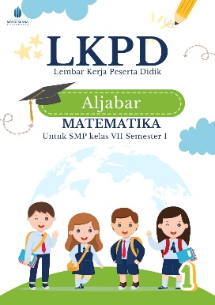 | 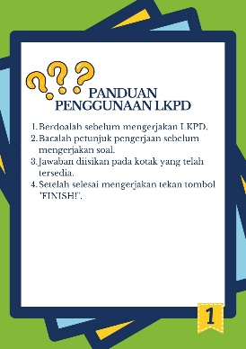 | 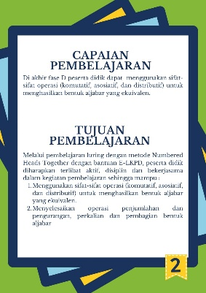 |  |  | 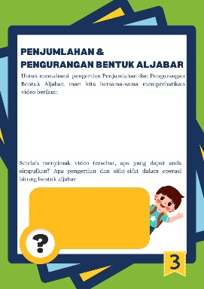
Figure 1 | Figure 2 |  | Figure 3 | Figure 4
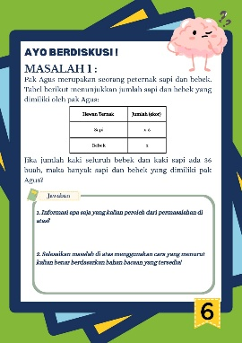 | 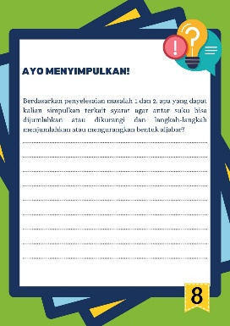 |  | 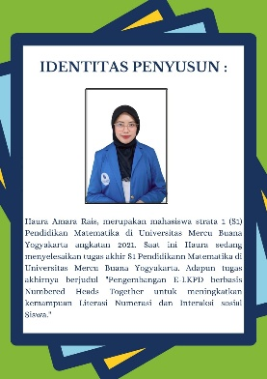
Figure 5 | Figure 6 |  | Figure 7

- Development Stage
At the development stage, the researcher compiled the design that had been created at the design stage into the form of an ELKPD so that it could be operated via an Android cellphone. ELKPD is used by students to help improve students' numeracy literacy skills and social interactions. Apart from that, the researcher prepared validation instruments including a material expert validation sheet and a media expert validation sheet. Then the researchers carried out an ELKPD assessment analysis of the results of material expert validation and media expert validation. The analysis was carried out using a Likert scale which was used to measure certain problems. Table 3 is a classification table of criteria resulting from material expert validation and media expert validation. Next are the scores from each material expert and media expert validator with the score weights as follows:

Table 3. Answer Assessment Weighting
Score | Category
5  4  3  2  1 | Very good  Good  Enough  Not good  Very Bad
After the validation stage, the results obtained are compared with the ideal criteria listed in Table 4 as follows:
Table 4. Classification of Criteria for Validation Results by Material Experts
No | Score | Category
1  2  3  4  5 | $$\overline{x}>63$$  $$51<\overline{x}≤63$$  $$39<\overline{x}≤51$$  $$27<\overline{x}≤39$$  $$\overline{x}≤27$$ | Very Valid  Valid  Quite Valid  Less Valid  Very Less Valid

Table 5. Classification of Media Expert Validation Criteria Results
No | Score | Category
1  2  3  4  5 | $$\overline{x}>58,8$$  $$47,6<\overline{x}≤58,8$$  $$36,4<\overline{x}≤47,6$$  $$25,2<\overline{x}≤36,4$$  $$\overline{x}≤25,2$$ | Very Valid  Valid  Quite Valid  Less Valid  Very Less Valid

The validation results by material experts and media experts are in Table 6 and Table 7 as follows:
Table 6. Validation by Material Experts
Validator | Position | Score | Criteria
Nuryadi, S.Pd.Si., M.Pd. | Lecturer of Mathematics Education, UMBY | 67 | Very Valid
Azhumna Hafidzatulistya | Mathematics Teacher at State Senior High School 2 Godean | 66 | Very Valid
Total Score |  |  | 133
Average |  |  | 66.5
Final Criteria |  |  | Very Valid

Table 7. Media Expert Validation
Validator | Position | Score | Criteria
Dr. Suharno, M.Pd | UMBY Lecturer | 60 | Very Valid
Nanang Khuzaini, M.Pd | Lecturer of Mathematics Education, UMBY | 65 | Very Valid
Total Score |  |  | 125
Average |  |  | 62.5
Final Criteria |  |  | Very Valid
The purpose of this study was to develop ELKPD learning media that was declared very valid for use by obtaining an average score of 66.7 from material experts and an average score of 62.5 from media experts. In the design stage, researchers considered input from students regarding media that were interesting according to students and could improve students' numeracy literacy and social interaction skills. So that the developed media contained examples and practice questions related to contextual problems. In the development stage, researchers sought opinions from two material expert validators and two media expert validators. Based on these opinions, researchers made improvements and discussed them again with the validators until the developed media was declared valid and suitable for use.

CONCLUSION
The ELKPD design is adapted to the steps of the students' numeracy literacy and social interaction ability indicators. The product developed uses the ADDIE model ( Analyze, Design, Development, Implementation, Evaluation ). The average value from the material expert validator shows 66.7 with very valid criteria, and the average value from the media expert validator shows 62.5 with very valid criteria. Overall, the level of validity of the developed learning media meets the very valid criteria, so it can be continued to the next development stage, namely the product's practicality and effectiveness test.

REFERENCES
Anderha, R. R. (2021). Pengaruh kemampuan numerasi dalam menyelesaikan masalah matematika terhadap prestasi belajar mahasiswa pendidikan matematika. Jurnal Ilmiah Matematika Realistik, 2(1),1-10.
Gestiardi, R. A. (2025). BELAJAR DAN PENGAJARAN MATEMATIKA DI ERA DIGITAL: SYSTEMATIC LITERATURE REVIEW. JP2M (Jurnal Pendidikan dan Pembelajaran Matematika), 11(1), 235-245.
Hibatulloh, R. W. (2024). Analisis Peran Teknologi dalam Perkembangan Pembelajaran Matematika di Era Digital. Diskusi Panel Nasional Pendidikan Matematika, 10. Diskusi Panel Nasional Pendidikan Matematika, 10.
Julita, J. &. (2022). Pemanfataan Teknologi sebagai Media Pembelajaran dalam Pendidikan Era Digital. Journal of Educational Learning and Innovation (ELIa), 2(2), 227-239.
Kusniati, I. (2018). Analisis Kemampuan Literasi Matematis peserta didik Melalui Penyelesaian Soal-Soal Ekspresi Aljabar di SMP Negeri 1 Lambu Kibang. Doctoral dissertation, UIN Raden Intan Lampung.
Rasilah, R. D. (2021). Technological, Pedagogical and Content Knowledge untuk Guru Matematika di Era Digital: Literature Review. Gema Wiralodra, 12(1), 84-94.
Siskawati, F. S. (2021). Profil kemampuan literasi numerasi di masa pandemi cov-19. KoPeN: Konferensi Pendidikan Nasional, 3(1), 253-261.

